**Analyze Big data with Hadoop**

1. Create an Amazon S3 bucket

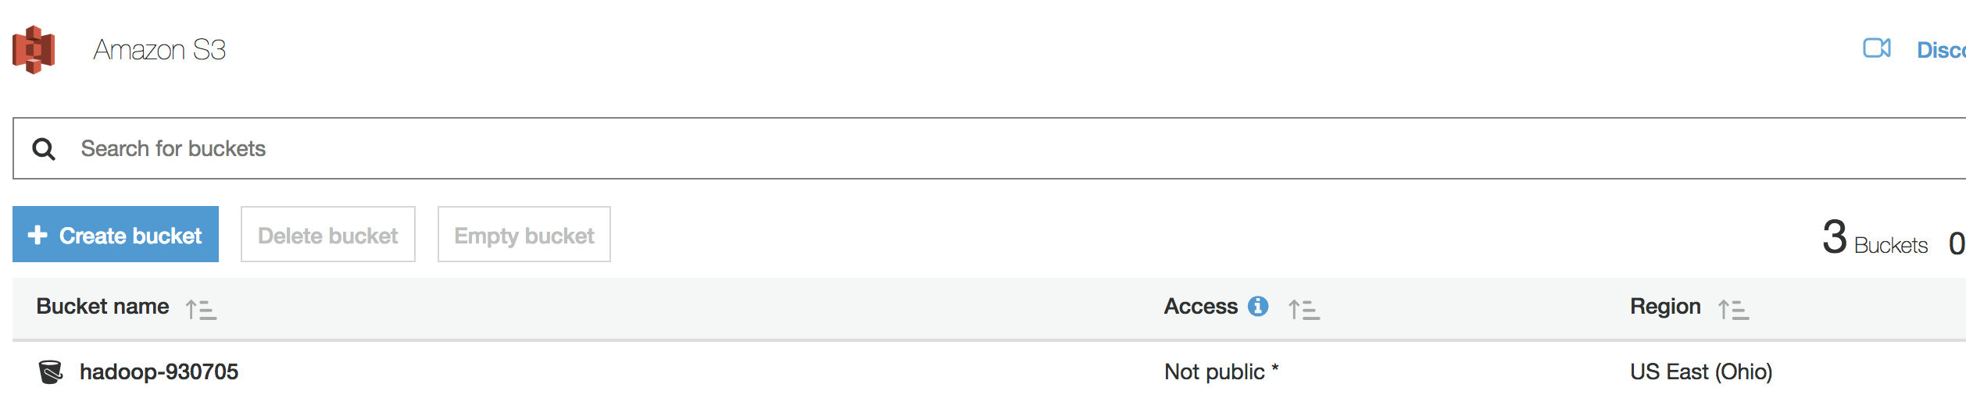

1. Launch an AWS EMR cluster

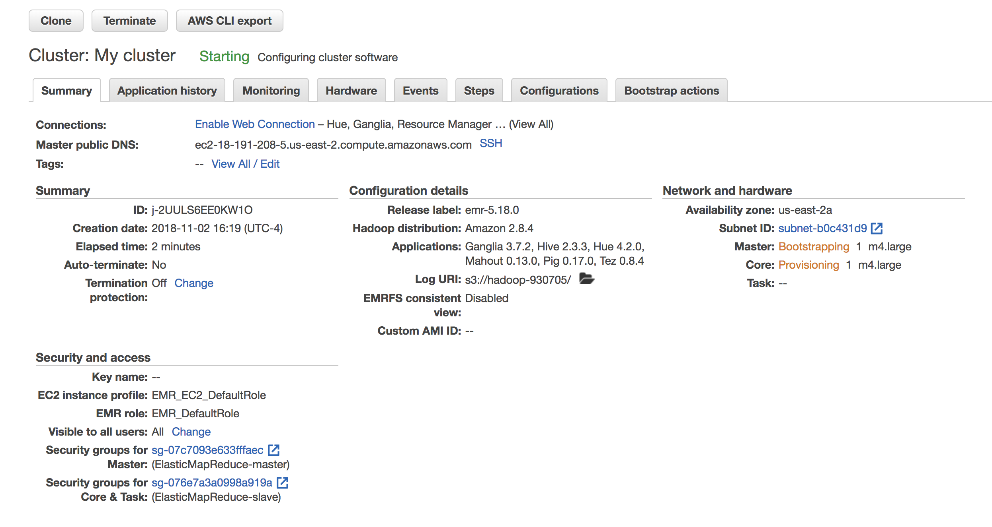

The several default application on the cluster:

* Apache Hadoop
* Ganglia
* Apache Taz
* Hue
* Pig

Data to be processed

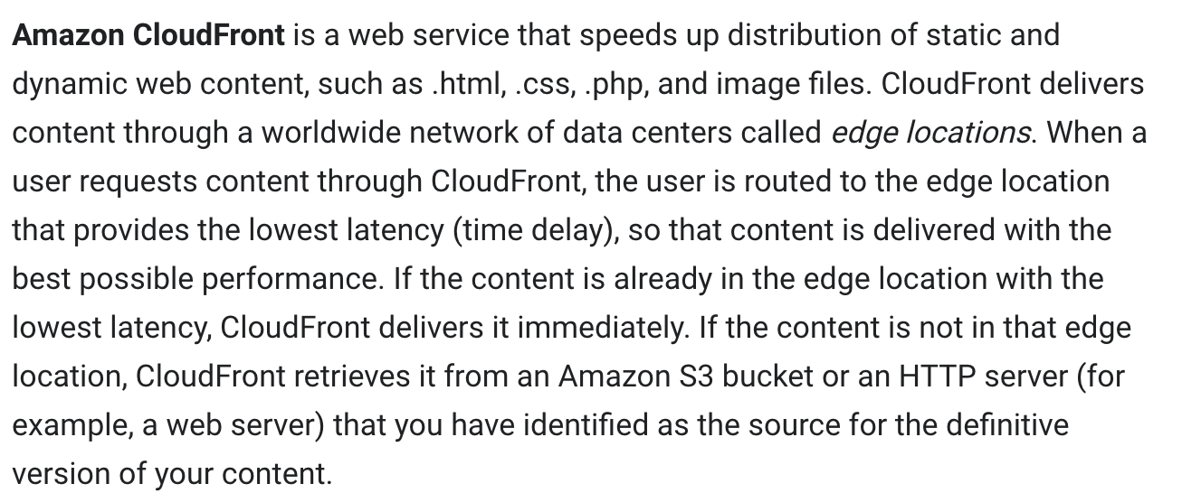

1. Running Hive script to process data

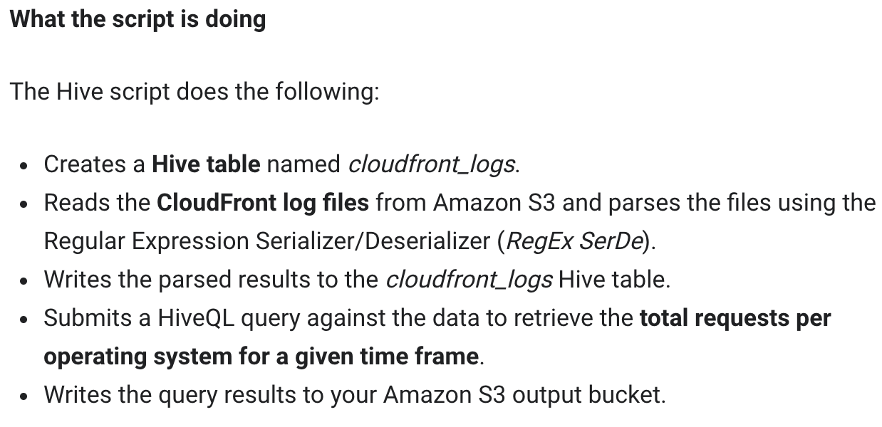

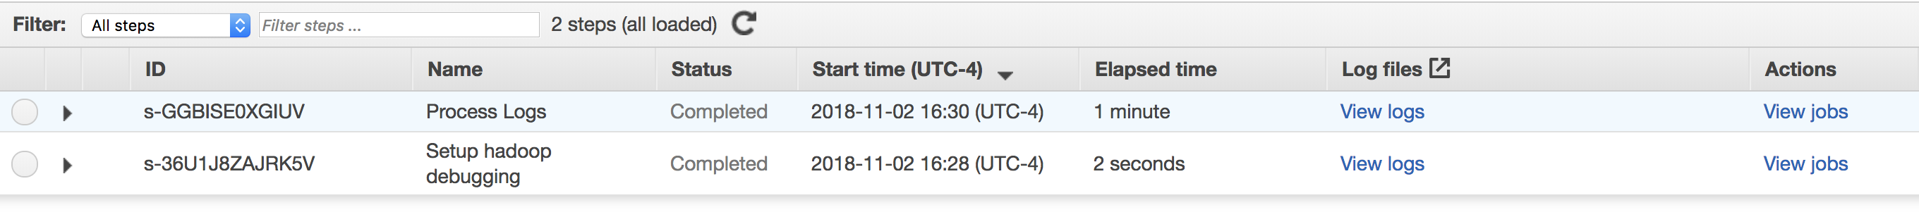

**Output:**

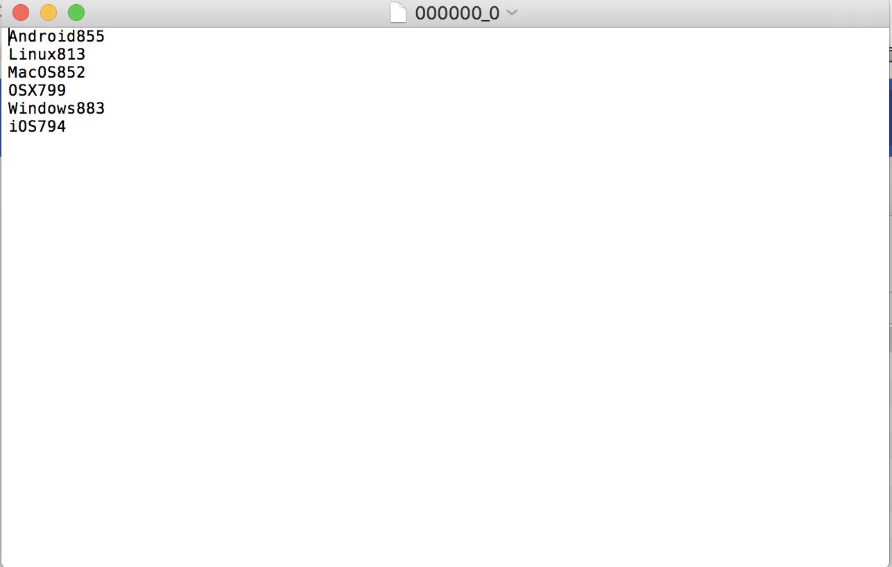

1. Terminate the cluster

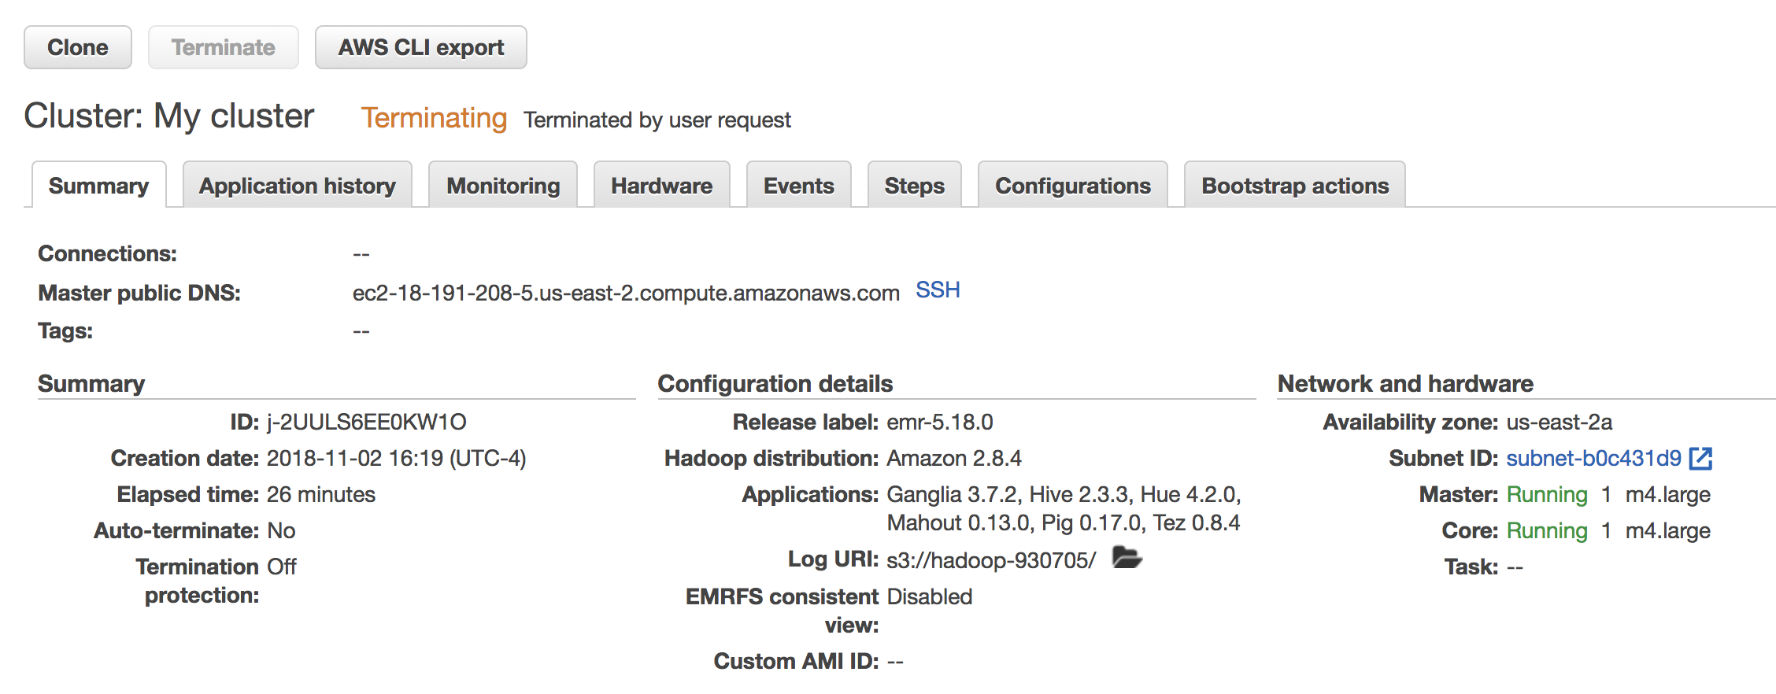

**Summary**

In this lab, I have learned the basic operation of AWS ECR, how to use Hadoop to process data and store it on AWS.